**Home Automation Using Packet Tracer**

**A Project Report**

**Submitted by**

**Project Timeline**

|  |  |
| --- | --- |
| Project Idea | |
| **Project Title** | **Home Automation Using Packet Tracer** |
| **scenario** | Many people are always on the move from place to place due to business demands. Some people can spend a couple of days away from their home leaving all their household appliances without any kind of monitoring and control. Some devices are left plugged into power sockets whereas others are supposed to be plugged into and out of power sockets at different intervals depending on the time of the day. All this requires an individual to manually attend to each of the devices independently from time to time. All such monitoring and control can be done without necessarily being around or inside the home. Some devices if not controlled properly consume a lot of energy which leads to extra expenditure on electricity. Therefore, we propose to design an internet-based home automation system which will enable one to remotely manage his/her appliances from anywhere, anytime. |
| **Project Timeline** | Consists of 12 weeks  There are weakly discussion between group members |
| **Weak one** | Choose group members and elect a leader |
| **Weak two** | Propose Project ideas and discuss it |
| **Weak three** | Literature Review and Planning |
| **Weak four** | Methodology |
| **Weak five** | Select working simulator & choose working topology |
| **Weak six** | Working with packet tracer |
| **Weak seven** | Begin writing final Report |
| **Weak eight** | Begin writing final presentation |
| **Weak nine** | Fix security issues & bugs during simulation |
| **Weak ten** | Finalizing lab simulation |
| **Weak eleven** | Report submission |
| **Weak twelve** | presentation |
|  |  |
|  |  |
| **Functional requirements** | Packet tracer Simulator Program |
| **Project features:** | 1. **RFID Based Door Lock:** Door can be unlocked only by using valid RFID card. If anyone wants to enter in the office, he or she has to show RFID. If the RFID is valid, the door will be opened, otherwise not. 2. **Smart Window, based on light and rain:** Smart Window which will be opened automatically when it’s morning time and there is no rain using rain sensor, photo sensor. If it’s night the window will be closed to avoid the mosquitoes even if there is rain. 3. **Solar Power battery charging:** Basing on solar power, fan and light will be running automatically. But, if the battery power finishes, they won’t be running. The battery only charges itself when there is sufficient light. 4. **Anti-theft protection:** To provide anti-theft protection trip sensor is being used, if anyone breaks window and enters trip sensor will give siren as alert. 5. **Auto fan & coffee maker:** When anyone enters the canteen, fan and coffee maker turns on itself detecting the motion. 6. **Music player:** Music can be played using music player via Bluetooth on a portable speaker. Entertainment purpose. 7. **Smart street lamp:** Turns on when it’s night using photo sensor. Energy saving. 8. **Smart garage:** Opens itself when detects smoke, means the car is turned on. Either it will be entering or going out. Garage door closes itself when there is no smoke, means either car is far or it’s turned off inside the garage. 9. **Fire alarm & smoke alarm:** If anything catches fire, the fire detector will give siren to alert everyone. If ridiculous amount of smoke is generated by vehicle, smoke detector will siren alert. 10. **RFID Based Door Lock:** Door can be unlocked only by using valid RFID card. If anyone wants to enter in the office, he or she has to show RFID. If the RFID is valid, the door will be opened, otherwise not. 11. **Smart Window, based on light and rain:** Smart Window which will be opened automatically when it’s morning time and there is no rain using rain sensor, photo sensor. If it’s night the window will be closed to avoid the mosquitoes even if there is rain. 12. **Solar Power battery charging:** Basing on solar power, fan and light will be running automatically. But, if the battery power finishes, they won’t be running. The battery only charges itself when there is sufficient light. 13. **Anti-theft protection:** To provide anti-theft protection trip sensor is being used, if anyone breaks window and enters trip sensor will give siren as alert. 14. **Auto fan & coffee maker:** When anyone enters the canteen, fan and coffee maker turns on itself detecting the motion. 15. **Music player:** Music can be played using music player via Bluetooth on a portable speaker. Entertainment purpose. 16. **Smart street lamp:** Turns on when it’s night using photo sensor. Energy saving. 17. **Smart garage:** Opens itself when detects smoke, means the car is turned on. Either it will be entering or going out. Garage door closes itself when there is no smoke, means either car is far or it’s turned off inside the garage. 18. **Fire alarm & smoke alarm:** If anything catches fire, the fire detector will give siren to alert everyone. If ridiculous amount of smoke is generated by vehicle, smoke detector will siren alert. |
| **IOT devices:** | Fan, light, Window, Garage, Door, Battery, Siren, Solar panel, Appliance, Portable music player, Motion Detector, Street lamp, Old car, Fire monitor, RFID card, RFID reader, Trip sensor, Fire sprinkler, Smoke detector.  **Sensors:** Custom made rain sensor, Photo sensor, Smoke sensor.  **Actuators:** Led, speaker, alarm. |

# Table of Contents

Contents

Table of Contents 6

**LIST OF FIGURES** 8

**LIST OF TABLE** 10

**ABBREVIATIONS** 11

**Problem Statement** 15

**Abstract** 16

**CHAPTER 1 INTRODUCTION** 19

**1.1.** **Introduction** 19

**Introduction** 19

**1.2.** **Objective** 22

**1.3.** **IoT definition** 22

**1.4.** **History and Evolution of IoT** 24

**1.5.** **IoT (Internet of Things) Applications:** 25

**1.6.** **Methodology** 28

**1.7.** **Implementation** 30

**1.8.** **Software Used** 30

**1.9.** **USED IOT Devices** 31

**CHAPTER 2 CISCO PACKET TRACER** 35

**2.1.** **Cisco Packet Tracer Overview** 35

**2.2.** **Packet tracer Workspaces:** 36

**2.3.** **Packet tracer Mode** 37

**2.4.** **Cisco devices configuration methods** 38

**2.5.** **Cisco packet tracer supported protocols:** 40

**2.6.** **Cisco packet tracer and Internet of Things:** 41

**CHAPTER 3 SMART HOME IMPLEMENTATION** 44

**3.1.** **Smart home overview** 44

**3.2.** **Smart home implementation** 44

**3.3.** **Methodology of the design:** 47

**3.4.** **Device Configuration and Setup:** 47

**3.5.** **Addressing Table** 48

**3.6.** **ASA Firewall** 51

**3.7.** **IPSEC VPN Tunnel** 52

**3.8.** **Remote Router IPSEC VPN Tunnel** 53

**3.9.** **Local Router IPSEC VPN Tunnel** 53

**3.10.** **EIGRP** 55

Local Router 55

Remote Router 55

ISP Ruoter 55

ASA 55

**3.11.** **DHCP service** 56

Local Router 56

Remote Router 56

ASA 56

**3.12.** **Server Reachability** 57

**3.13.** **Devices configuration** 57

**3.14.** **Server Configuration** 62

**3.15.** **Set username and password for IOT server** 63

**3.16.** **Register to IOT server** 64

**3.17.** **Manage IOT devices** 66

Login to server and choose IOT Monitor 66

Login to server 1.0.0.8 66

**3.18.** **ISP Router** 71

**3.19.** **Remote Router** 74

**3.20.** **Local Router** 76

**Results** 79

**3.21.** **Result of implementation:** **Error! Bookmark not defined.**

**Conclusion** 80

CHAPTER 4 CONCLUSION 83

**4.1. Conclusion:** 83

**4.2. Future Research** 84

**References** 85

# **LIST OF FIGURES**

Figure 1 Iot Applications 27

Figure 2 Home gateway 28

Figure 3 available services 30

Figure 4 packet tracer 36

Figure 5 Physical View of ISP Router 37

Figure 6 Cisco Packet Tracer Command Line Interface Tab 39

Figure 7 Cisco Packet Tracer Config Tab 40

Figure 8 Smart home Application 45

Figure 9 simulation topology 47

Figure 10 simulation topology 48

Figure 11 ipsec VPN 52

Figure 12 server reachability 57

Figure 13 topology 58

Figure 14 home gateway 59

Figure 15 Home Gateway 60

Figure 16 Smart Light Connected to the Home Gateway 61

Figure 17 server configuration 62

Figure 18 set username and password for IOT server 63

Figure 19 Connecting IoT Devices to IoT Server 64

Figure 20 Connecting IoT Devices to IoT Server 65

Figure 21 iot monitor access 66

Figure 22 login to IOT server 67

Figure 23 IOT managed services 68

Figure 24 IOT managed services 69

Figure 25 IOT managed services 70

Figure 26 Smart Phone Physical View 71

Figure 27 iot devices after action 79

# **LIST OF TABLE**

Table 1 Protocol Supported by Cisco Packet Tracer 40

Table 2 Devices Used for the Simulation 45

Table 3 Addressing Table 48

Table 4 ASA configuration 51

Table 5 remote router configuration 53

Table 6 local router configuration 53

Table 7 eigrp 55

Table 8 Enable DHCP service 56

Table 9 ISP router 71

Table 10 remote router 74

Table 11 local router 76

# **ABBREVIATIONS**

|  |  |
| --- | --- |
| 3GPP | 3rd Generation Partnership Project |
| API | Application Programming Interface |
| APN | Access Point Name |
| ARPANET | Advanced Research Project Agency Network |
| CLI | Command Line Interface |
| DHCP | Dynamic Host Configuration Protocol |
| DNS | Domain Name System |
| GUI | Graphical User Interface |
| IaaS | Infrastructure as a Service |
| IoE | Internet of Everything |
| IoT | Internet of Things |
| ISP | Internet Service Provider |
| LAN | Local Area Network |
| NetAcad | Cisco Networking Academy |
| RFID | Radio Frequency Identification |
| RIP | Routing Information Protocol |
| SaaS | Software as a Service |
| POP3 | Post Office Protocol version 3 |
| Telnet | TELecommunications NETwork |
| SSH | Secure Socket Shell |
| DSL | Digital Subscriber Line |
| FTP | File Transfer Protocol |
| SMTP | Simple Mail Transfer Protocol |
| HTTP | Hypertext Transfer Protocol |
| TFTP | Trivial File Transfer Protocol |
| AAA | Authentication, Authorization, and Accounting |
| NTP | Network Time Protocol |
| SNMP | Simple Network Management Protocol |
| VOIP | Voice-Over-IP |
| SCCP | Signaling Connection Control Part |
| ISR | International Standard Recording |
| TCP | Transmission Control Protocol |
| UDP | User Datagram Protocol |
| BGP | Border Gateway Protocol(TCP/IP) |
| ICMP | Internet Control Message Protocol |
| IP | Internet Protocol |
| ARP | Address Resolution Protocol |
| NAT | Network address translation |
| GRE | Generic Routing Encapsulation |
| IPSec | IP Security |
| VPN | Virtual Private Network |
| HDLC | High-level Data Link Control |
| PPP | Point to Point Protocol |
| STP | Spanning-Tree Protocol |
| PPPoE | PPP Over Ethernet |
| DTP | Data Transfer Process |
| VTP | VLAN Trunking Protocol |
| QoS | Quality Of Service |
| CDP | CRL Distribution Point [Microsoft |
| WEP | Wired Equivalent Privacy |
| SLARP | Serial Line Address Resolution Protocol |
| WAN | Wide-Area Network |
| WAP | Wireless Access Protocol |
| TCP/IP | Transmission Control Protocol/Internet Protocol |
| EAP | Extensible Authentication Protocol [Microsoft] |
| PKT | Packet Tracer file extension |
| PSK | Phase Shift Keying |
| SSID | Service set identifier |
|  |  |

# **Problem Statement**

Many people are always on the move from place to place due to business demands. Some people can spend a couple of days away from their home leaving all their household appliances without any kind of monitoring and control. Some devices are left plugged into power sockets whereas others are supposed to be plugged into and out of power sockets at different intervals depending on the time of the day. All this requires an individual to manually attend to each of the devices independently from time to time. All such monitoring and control can be done without necessarily being around or inside the home. Some devices if not controlled properly consume a lot of energy which leads to extra expenditure on electricity. Therefore, we propose to design an internet-based home automation system which will enable one to remotely manage his/her appliances from anywhere, anytime.

# **Abstract**

The Home Automation is a wireless home automation system that is supposed to be implemented in existing home environments, without any changes in the infrastructure. Home Automation let the user to control the home from his or her computer and assignations that should happen depending on time or other sensor readings such as light, temperature or sound from any device in the Home Automation network

With advancement of Automation technology, life is getting simpler and easier in all aspects. In today’s world Automatic systems are being preferred over manual system. With the rapid increase in the number of users of internet over the past decade has made Internet a part and parcel of life, and IoT is the latest and emerging internet technology. Internet of things is a growing network of everyday object-from industrial machine to consumer goods that can share information and complete tasks while you are busy with other activities. Wireless Home Automation system (WHAS) using IoT is a system that uses computers or mobile devices to control basic home functions and features automatically through internet from anywhere around the world, an automated home is sometimes called a smart home. It is meant to save the electric power and human energy. The home automation system differs from other system by allowing the user to operate the system from anywhere around the world through internet connection. In this project I present a Home Automation system (HAS) using Cisco Packet Tracer, to provide the user with remote control of various lights, fans, and appliances within their home. The system will automatically change on the basis of sensors’ data. This system is designed to be low cost and expandable allowing a variety of devices to be controlled.

CHAPTER 1 Introduction

# **CHAPTER 1 INTRODUCTION**

# **Introduction**

Computer networks are considered to be very complex and difficult to implement and operate. Moreover, with IoT (internet of things) technology, where we connect any sort of devices on internet such as refrigerator, air conditioner, fan etc. this complexity becomes even higher. Cisco packet tracer is a powerful software created by Cisco Company for simulating virtual networks, especially wireless networks. Cisco packet tracer gives an environment where devices look what they do in reality, and this is very important for users especially students. They can monitor and interact with different wireless and IoT devices in virtual environment before working in real time.

# **Introduction**

Homes of the 21st century will become more and more self-controlled and automated due to the comfort it provides, especially when employed in a private home. A home automation system is a means that allow users to control electric appliances of varying kind. Many existing, well-established home automation systems are based on wired communication. This does not pose a problem until the system is planned well in advance and installed during the physical construction of the building. But for already existing buildings the implementation cost goes very high.

In contrast, Wireless systems can be of great help for automation systems. With the advancement of wireless technologies such as Wi-Fi, wireless systems are used every day and everywhere.

Advantages of Home automation systems:

In recent years, wireless systems like Wi-Fi have become more and more common in-home networking. Also, in home and building automation systems, the use of wireless technologies gives several advantages that could not be achieved using a wired network only.

1) Reduced installation costs: First and foremost, installation costs are significantly reduced since no cabling is necessary. Wired solutions require cabling, where material as well as the professional laying of cables (e.g. into walls) is expensive.

2) System scalability and easy extension: Deploying a wireless network is especially advantageous when, due to new or changed requirements, extension of the network is necessary. In contrast to wired installations, in which cabling extension is tedious. This makes wireless installations a seminal investment.

3) Aesthetical benefits: Apart from covering a larger area, this attribute helps to full aesthetical requirements as well. Examples include representative buildings with all-glass architecture and historical buildings where design or conservatory reasons do not allow laying of cables.

4) Integration of mobile devices: With wireless networks, associating mobile devices such as PDAs and Smartphones with the automation system becomes possible everywhere and at any time, as a device's exact physical location is no longer crucial for a connection (as long as the device is in reach of the network).

For all these reasons, wireless technology is not only an attractive choice in renovation and refurbishment, but also for new installations.

Home Automation is automation of home, housework or household activity. In other words, it refers to use of IT/computer to control home appliances. It integrates electrical devices in a house with each other. For example: It can include centralized control of lighting, appliances, security lock of gates & doors to provide improved convenience, comfort, energy, efficiency and safety. In today's IT world, home automation is being popular due to easiness, flexible means of viewing/monitoring and controlling the appliances and other things according to user’s comfort and needs. The challenging part lies in simplicity and cost of installing them in home and varies with increasing number of services to be monitored and controlled. This project named 'HOME AUTOMATION USING PACKET TRACER’ is idea of home automation using Cisco Packet Tracer. The popularity of home automation has been increasing greatly in recent years due to considerable affordability and simplicity through smartphone and tablet connectivity. A home automation system integrates electrical devices in a house with each other. The techniques employed in home automation include those in building automation as well as the control of domestic activities, such as lighting control system, and the use of other electrical appliances. Devices may be connected through a home network to allow control by a personal computer and may allow remote access from the internet. Through the integration of information technologies with the home environment, systems and appliances can communicate in an integrated manner which results in convenience, energy efficiency, and safety benefits. Due to the advancement of wireless technology, there are several different of connections are introduced such as GSM, WIFI, and Bluetooth. Each of the connection has their own unique specifications and applications. Among the four popular wireless connections that often implemented in Home Automation project, WIFI is being chosen with its suitable capability. The capabilities of WIFI are more than enough to be implemented in the design. Also, most of the current laptop/notebook or Smartphone come with built-in WIFI adapter. It will indirectly reduce the cost of this system.

This project deals about implementing smart home using new released cisco packet tracer because this feature includes different sensor, actuator and different smart device used for home automation. Some of the device are smart window, smart light, smart door, smart fan with different detector and sensor. To implement smart home, I used new released cisco packet tracer simulation software to design and configure IOE device with classically networking device.

# **Objective**

The main objectives of our project are as follows:

1. To remotely control home appliances and monitor them.
2. To save time and utilize the energy efficiently
3. To increase your independence and achieve greater control of home environment
4. To make it easier to communicate with family
5. To improve personal safety
6. To alert visually to emergency situations

# **IoT definition**

Internet of things or internet of everything refer to the idea of thing (object), that are readable, recognizable, locatable, addressable through information sensing devices (sensor) and controllable via internet. Things are physical objects with unique identifiers that are able to transfer data over the network. Examples of physical objects include vehicles, smart phones, home appliances, toys, cameras, medical instruments and industrial systems, animals, people, buildings, etc. Internet of Things is a new revolutionary and advanced technology where any object becomes smart object, and where they can communicate information about themselves without human intervention. The Internet of Things is expected to make a huge change in our lives; it will help us to perform our tasks and duties in a better way.

# **History and Evolution of IoT**

The very first idea of IoT started with Coca Cola vending machines in 1980s at the Carnegie Melon University, students from the department of computer science install micro- switches into the machine to see if the cooling devices was keeping the drinks cold enough and if there were available coke cans in the machine via internet. This first invention encourage further studies on interconnected machines. Later in 1990s, with a TCP/IP protocol John Romkey connected a toaster to the internet for the first time.

In 1991 at Cambridge University, Scientist developed a system to check to amount of coffee available in the coffee machine. The idea was to use the webcam to take picture of the coffee pot three time a minute and send to local computer located in their lab so everyone could see the amount of coffee.

In 1991, Kevin Ashton introduce the concept of the internet of things (IoT) in a presentation paper for Procter & Gamble. In the presentation, he explained the internet of things as a technology that connected devices Using RFID (radio frequency and identification) technology.

In 2008, scientists from 23 countries were regrouped in Switzerland at the first international conference on the internet of things, to discuss about the RFID, short- range wireless communications and sensor networks.

2010 was the true birth of the internet of things according to cisco because of the number of the interconnected devices. They also said that the number of interconnected devices passed the number of people on earth.

In 2015, the number of connected devices has significantly exceed the number of people. We can see in the figure above that in the present year (2020) they are 50 billion and the world population is 7.6 billion people. This show that the number of connected devices are six times more the number of human.

It is expected that in the future, all things will be able to connect to each other. Things not including just electronic devices but also books, shoes, foods, water etc.

# **IoT (Internet of Things) Applications:**

Internet of things is the technology that will make a big impact in our life. This technology is utilizing in many sector for instance agriculture, energy healthcare, transports, and many more. In this section, I will describe some of the real world applications of internet of things.

**Industrial Internet of Things (IIoT):**

Internet of things is used in the industry field to improve the productivity and performance. For example, the internet of things devices can be used to monitor and control the process of the factory and for maintenance; it can be used to detect corrosion inside a refinery pipe, or to predict about the malfunctions of some equipment in order to provide maintenance services before it get too late. The use of internet of things in the industries will help variety of industries including manufacturing, food industries, automotive industries, etc. to get work done easily.

**Internet of Medical Things (IoMT):**

The medical sector will be the one to benefit the internet of things technology the most. Internet of things in healthcare give the possibility to the doctors possible to control patient conditions anywhere anytime over network in order to provide monitoring, analysis and remote configurations through smart devices such as heart monitors and pace makers. Many others internet of things devices can be used to control our health such as fitness trackers and smart watches etc.

**Smart Cities:**

Smart cities refer to a city where internet of things devices are used to control and monitor the transportations and infrastructures in the city. Internet of things devices can also be used in smart city to control others sectors or activities in the cities rather than transportations or infrastructures such as controlling the quality of the water, or analyzing and monitoring the energy system, and many more.

**Smart Homes:**

Smart home refer to a home equipped with smart appliances, fridge, air conditions, light, camera, fan, smart thermostats, door locks etc. that can be remotely control and manage through internet using smart phone or computer. The possibility to manage to manage the home equipment from distance offer homeowner security, comfort and convenience. Smart home help saving energy and avoids some accidents, homeowner can remotely monitor the camera, home alarm system, and detection system to check if there is any violations for security reason.

**Smart Cars:**

Smart car is a system where all the functionalities of the car can be remotely control by a computer or a smart smartphone with the use of different sensors. With This particular internet of things application, we can check the car oil level, radiator water, and even being capable to drive the car from distance.

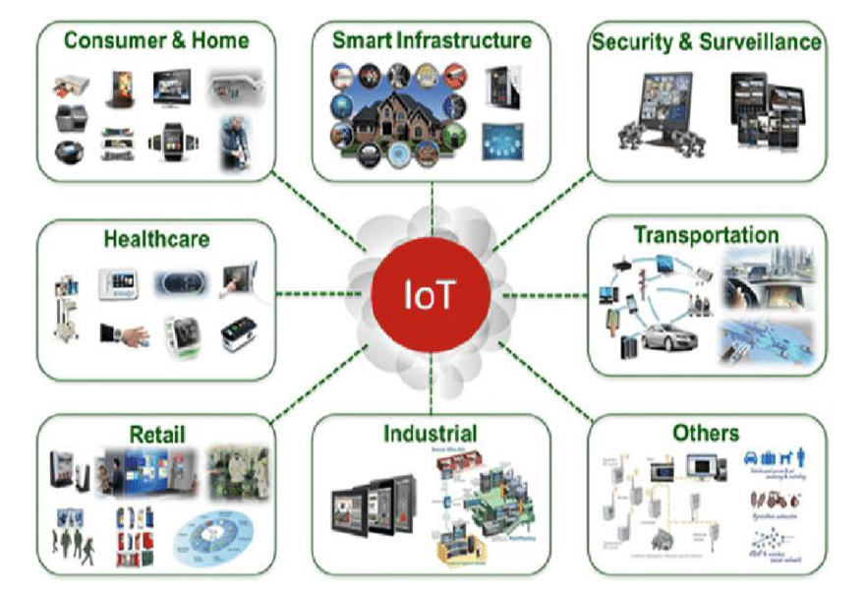

Figure Iot Applications

# **Methodology**

In order to implement smart home, I used new released cisco packet tracer, which included different smart object used for home automation such as smart fan, smart window, smart door, smart light, smart siren, smart webcam and different sensor is included.

To control this smart object and sensor, Home Gateway is used, since it provides programming environment for controlling smart object connected to it and provide controlling mechanisms by registering smart device to Home Gateway respectively.

Home Gateway:

Home Gateway have 4 Ethernet ports in addition to a wireless access point configured with the "Home Gateway" SSID. To secure wireless connection WEP / WPA-PSK / WPA2 enterprise can be configured on home gateway.

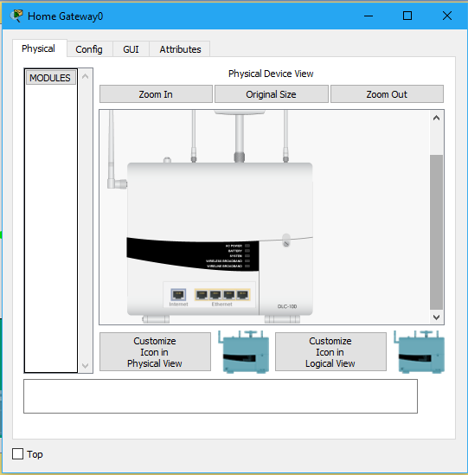

Figure Home gateway

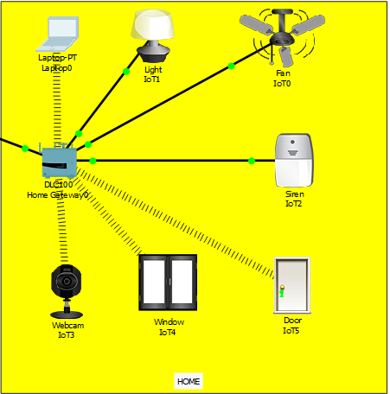

The figure shows six internet of Things device connected to a Home Gateway by using Ethernet cable and wireless. To connect the Home Gateway to the Internet its Internet WAN Ethernet port available on home getaway. The IoE device can be remotely managed through a web interface hosted by the Home Gateway. The Home Gateway internal (LAN) IP address is 192.168.25.1 but it can also be accessed through its Internet facing IP address.

The above figure shows the smart object is connected to the home Gateway using Ethernet cable and wireless medium to manage smart device local and remotely. Home gateway also works as DHCP server by assigning IP address to each smart device that connected to it, used to interconnect different smart object.

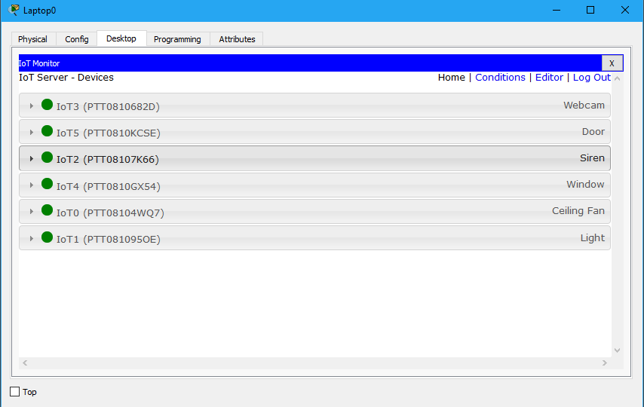

Figure available services

The above figure shows after registering smart device to home gateway all devices are accessed through web by legitimate user. There are six IOE device registered to Home gateway those all are controlled through web by legitimate person.

# **Implementation**

# **Software Used**

Cisco Packet Tracer (<https://www.netacad.com/courses/packet-tracer>)

Sublime Text 3 (<https://www.sublimetext.com/3>)

Currently cisco released new version of packet tracer that include IOE device with classically networking device. Boards is also added to this version those are microcontrollers (MCU-PT), single boarded computers (SBC-PT) that provide programming environment to control connected object.

Benefits of new released Packet Tracer are:

* Offers a realistic simulation and visualization of IOT device
* Permits users to design, build, configure smart home, smart city by providing different smart object used for them.
* Provide board to control smart object
* Allows students to explore concepts IOE
* Provide detector for sensor

# **USED IOT Devices**

Fan, light, Window, Garage, Door, Battery, Siren, Solar panel, Appliance, Portable music player, Motion Detector, Street lamp, Old car, Fire monitor, RFID card, RFID reader, Trip sensor, Fire sprinkler, Smoke detector.

**Sensors:** Custom made rain sensor, Photo sensor, Smoke sensor.

**Actuators:** Led, speaker, alarm.

1. **RFID Based Door Lock:** Door can be unlocked only by using valid RFID card. If anyone wants to enter in the office, he or she has to show RFID. If the RFID is valid, the door will be opened, otherwise not.
2. **Smart Window, based on light and rain:** Smart Window which will be opened automatically when it’s morning time and there is no rain using rain sensor, photo sensor. If it’s night the window will be closed to avoid the mosquitoes even if there is rain.
3. **Solar Power battery charging:** Basing on solar power, fan and light will be running automatically. But, if the battery power finishes, they won’t be running. The battery only charges itself when there is sufficient light.
4. **Anti-theft protection:** To provide anti-theft protection trip sensor is being used, if anyone breaks window and enters trip sensor will give siren as alert.
5. **Auto fan & coffee maker:** When anyone enters the canteen, fan and coffee maker turns on itself detecting the motion.
6. **Music player:** Music can be played using music player via Bluetooth on a portable speaker. Entertainment purpose.
7. **Smart street lamp:** Turns on when it’s night using photo sensor. Energy saving.
8. **Smart garage:** Opens itself when detects smoke, means the car is turned on. Either it will be entering or going out. Garage door closes itself when there is no smoke, means either car is far or it’s turned off inside the garage.
9. **Fire alarm & smoke alarm:** If anything catches fire, the fire detector will give siren to alert everyone. If ridiculous amount of smoke is generated by vehicle, smoke detector will siren alert.
10. **RFID Based Door Lock:** Door can be unlocked only by using valid RFID card. If anyone wants to enter in the office, he or she has to show RFID. If the RFID is valid, the door will be opened, otherwise not.
11. **Smart Window, based on light and rain:** Smart Window which will be opened automatically when it’s morning time and there is no rain using rain sensor, photo sensor. If it’s night the window will be closed to avoid the mosquitoes even if there is rain.
12. **Solar Power battery charging:** Basing on solar power, fan and light will be running automatically. But, if the battery power finishes, they won’t be running. The battery only charges itself when there is sufficient light.
13. **Anti-theft protection:** To provide anti-theft protection trip sensor is being used, if anyone breaks window and enters trip sensor will give siren as alert.
14. **Auto fan & coffee maker:** When anyone enters the canteen, fan and coffee maker turns on itself detecting the motion.
15. **Music player:** Music can be played using music player via Bluetooth on a portable speaker. Entertainment purpose.
16. **Smart street lamp:** Turns on when it’s night using photo sensor. Energy saving.
17. **Smart garage:** Opens itself when detects smoke, means the car is turned on. Either it will be entering or going out. Garage door closes itself when there is no smoke, means either car is far or it’s turned off inside the garage.
18. **Fire alarm & smoke alarm**: If anything catches fire, the fire detector will give siren to alert everyone. If ridiculous amount of smoke is generated by vehicle, smoke detector will siren alert.

CHAPTER 2 Cisco Packet tracer

# **CHAPTER 2 CISCO PACKET TRACER**

# **Cisco Packet Tracer Overview**

Cisco packet tracer is a powerful virtual network simulation tool used to learn and understand different concept in computer networks. The tool is developed by Cisco in order to allow students or user to get practical networking technology knowledge.

Cisco packet tracer provide user / student to design and simulate a network by using virtual devices such as hub, router, switches etc. In cisco packet tracer, the simulation works without having any physical network.

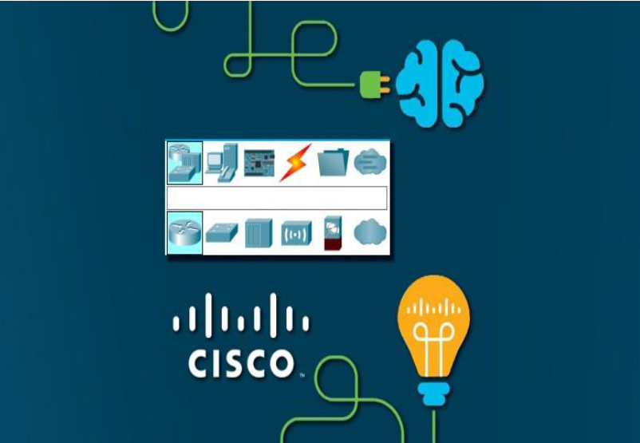

Figure packet tracer

Figure 2.1. Cisco Packet Tracer Interface

# **Packet tracer Workspaces:**

Cisco packet has two Workspaces: one is Physical and the other one logical. The logical view allow user to place and connect virtual network devices while the physical view gives a graphical representation of the virtual network devices. In the physical view of the devices, we can add additional modules to an available slot in the devices. The good thing about this particular simulation tool is that it provide an environment where devices resemble to devices in the real world. This is very important because it give user the possibility to be familiar with devices before working with the real equipment.

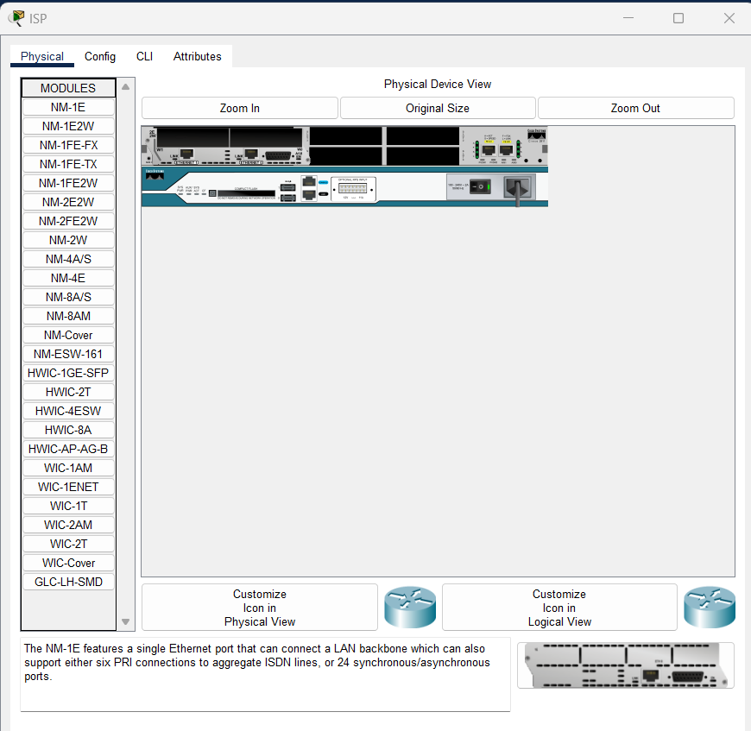

Figure Physical View of ISP Router

# **Packet tracer Mode**

The tool also provide two mode, which are real time mode, and simulation mode.

In the real time, students/ user can have a clear vison of how the devices behaves. In this mode, devices behave as real devices. In the other hand, the simulation mode help students / user to understand the fundamental concept behind the network operations. This mode permit user to see and control time intervals, and to visualize the propagation of data across a network.

# **Cisco devices configuration methods**

Cisco packet tracer allow us to configure devices using two options: config tab or CLI tab (command line interface). With command line interface, we configure devices using cisco command line. The advantage of using the command line interface is that, the commands we use to configure devices virtually are the same command we use with the real devices.

The Figure 2.3 below represents a router configuration using a Command line interface (CLI). The config tab did not required any cisco commands knowledge. Configuration with config tab is done through a graphical interface. This configuration method can be use in the situation where user does not have enough time and want to configure devices quickly. This technique can help us saving time during configuration. The Figure 2.4 represent a router configuration with Config Tab.

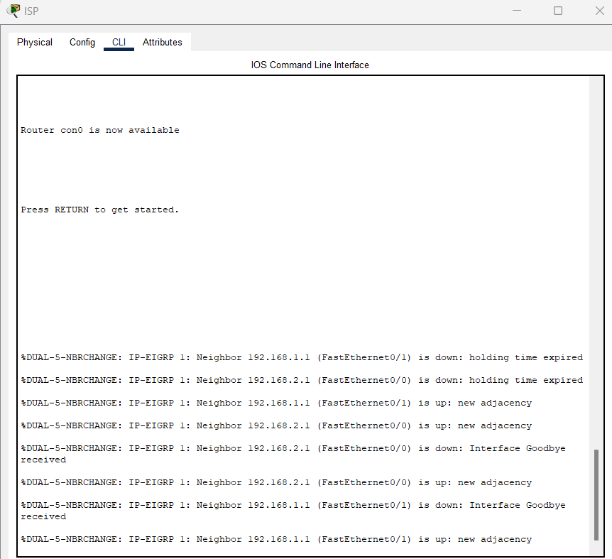

Figure Cisco Packet Tracer Command Line Interface Tab

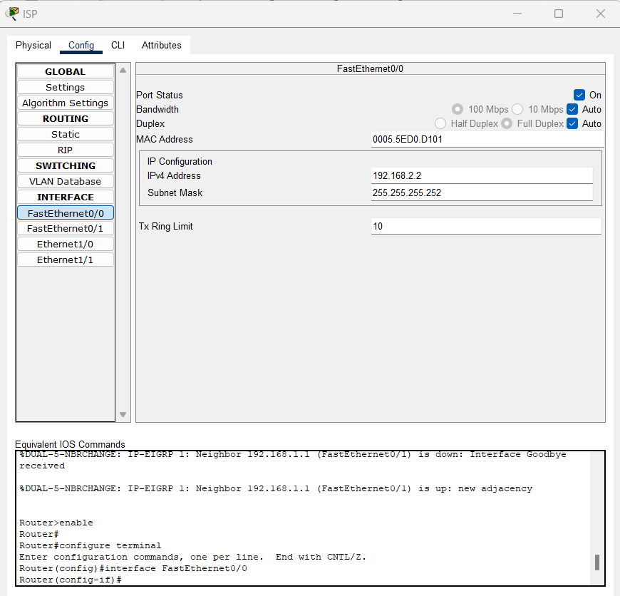

Figure Cisco Packet Tracer Config Tab

# **Cisco packet tracer supported protocols:**

Cisco packet tracer support different protocols. The table below show the lists of protocols supported by packet tracer.

Table Protocol Supported by Cisco Packet Tracer

|  |  |
| --- | --- |
| Layer | Protocols |
| Application | FTP,SMTP, POP3, HTTP, TFTP, Telnet, SSH, DNS, DHCP, NTP, SNMP,AAA, ISR VOIP, SCCP config and calls ISR command support, Call Manager Express |
| Transport | TCP and UDP, TCP Nagle Algorithm & IP Fragmentation, RTP |
| Network | BGP, IPv4, ICMP, ARP, IPv6, ICMPv6, IPSec, RIPv1/ v2/ng, Multi-Area OSPF, EIGRP, Static Routing, Route Redistribution, Multilayer Switching, L3 QoS, NAT, CBAL, Zone-based policy firewall and Intrusion Protection System on the ISR, GRE VPN, IPSec VPN |
| Network Access/ Interface | Interface Ethernet (802.3), 802.11, HDLC, Frame Relay, PPP, PPPoE, STP, RSTP, VTP, DTP, CDP, 802.1q, PAgP, L2 QoS, SLARP, Simple WEP, WPA, EAP |

# **Cisco packet tracer and Internet of Things:**

The last version of cisco packet tracer included some new feature that can help us to perform internet of things simulation. Those new feature are smart devices, sensor, actuator and microcontroller. Some of those smart devices included in packet tracer are smart windows, smart fan, smart light, alarm siren.

There are different cabling options in the new packet tracer, which are copper straight cables, copper crossover cables, and optic fast-Ethernet cables and IoT custom cables. Nevertheless, we can also choose the auto cabling option where the tools automatically choose the suitable cable to connect two devices. The internet of things devices in the Cisco Packet tracer can be used to build and simulate different internet of things application such as smart home, smart industry, smart city etc.

The benefit of using cisco packet tracer is that, user can interact with the devices the same way they do in the real devices. In addition, with it multiuser functionality, multiuser can work together to build virtual network through a real network.

This thesis work is only focusing on using the smart devices in the new version of the packet tracer to implement a smart home or internet based home automation system.

CHAPTER 3 SMART HOME IMPLEMENTATION

# **CHAPTER 3 SMART HOME IMPLEMENTATION**

# **Smart home overview**

Smart home is a home equipped with different smart objects such smart fan, smart light, coffee maker, smart windows that can be remotely controlled via a smartphone or computer through internet connection. Smart home offer the homeowners convenience, savings, safety, and comfort. Saving because the use of some smart objects such as smart thermostats and smart light can help for energy saving (reduce energy consumption) and reduce bills. It is convenience because every tasks are done automatically, and safety is one of biggest benefits of a smart home, because you can remotely control the devices and see if there is a danger at any time in your home.

Comfort because of the possibility it offer, imagine that you have the possibility to turn on your air conditioner to cool down the place before you reach your home, and also the possibly to check if there are foods in your refrigerator, or even to check if some foods inside your refrigerator are expiring or finishing. Smart home allows homeowner to manage all the home devices anywhere at any time.

# **Smart home implementation**

The implementation of the smart home is done with the new version of packet tracer,. The Table 3.1 below shows the lists of the different devices used for the simulation and their functions.

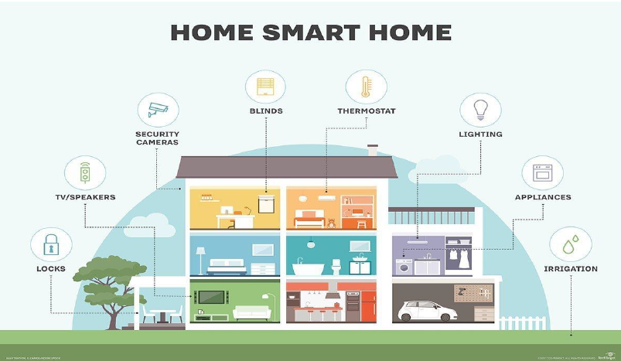

Figure Smart home Application

Table Devices Used for the Simulation

|  |  |  |
| --- | --- | --- |
|  | Devices | Function |
|  | Router (2911) / ISP | Used to connects cellular network to home |
|  | Cable modem | Used to home gateway to cloud |
|  | Home gateway | Used for smart devices registration |
|  | IoT server | Used to control smart devices registered on it |
|  | DNS server | Used to access smart devices by domain name |
|  | Central office server | Used to connect cell tower to router and vice versa |
|  | Cell tower | Used to connect the smartphone to the internet |
|  | Smart phone | Used to remotely access smart devices |
|  | Fan | Used to ventilate home |
|  | camera | Used to control activities at home |
|  | Smart light | Used for lightning the home |
|  | Smart door | Used in order to open and close the door from distance |
|  | Smart windows | Used to control the windows from distance |
|  | Smart siren | Used to make sound if anything happen at home |
|  | Motion detector | Used to detect motion |
|  | Air conditioner | Used for home cooling |
|  | Lawn sprinkler | Used the sprinkler the garden |
|  | Old car | Used in order to control the car from distance |
|  | Garage | Used to control the garage door |
|  | Solar panel | Used to provide energy to the home |
|  | Battery | Used with solar panel to provide energy |
|  | laptop | Connect to the home gateway to access the smart devices |
|  | Coffee maker | Used to control the coffee machine |

# **Methodology of the design:**

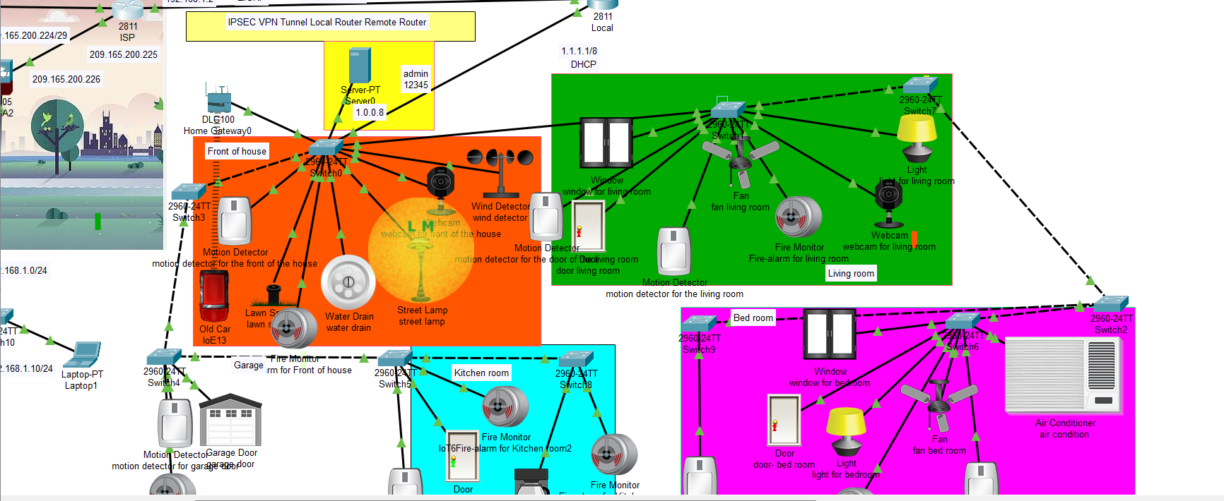

Figure simulation topology

The network topology used for the implementation of the smart home is represented in the Figure 3.3 above. The implementation consist of : the smart home, internet, Iot server. In the first part, we have a home network with different internet of things devices connected to the home gateway (home Wi-Fi router in the topology). The second part of the network is the internet cloud (WAN) which is connected to the home Wi-Fi router through a cable modem in order to provide internet connection to the internet of things devices. The third part concern the IoT (internet of things) server that register all the devices connected to it to provide more internet of things functionalities. Then comes the last part of the topology “3G network”, the smart phone is connected to the cell tower for internet connection in order to remotely access the devices

# **Device Configuration and Setup:**

To implement smart home using cisco packet tracer I used different sensor, smart device and detector to make smarter. The following figure represent the home architecture that connected each other using wireless and wired medium.

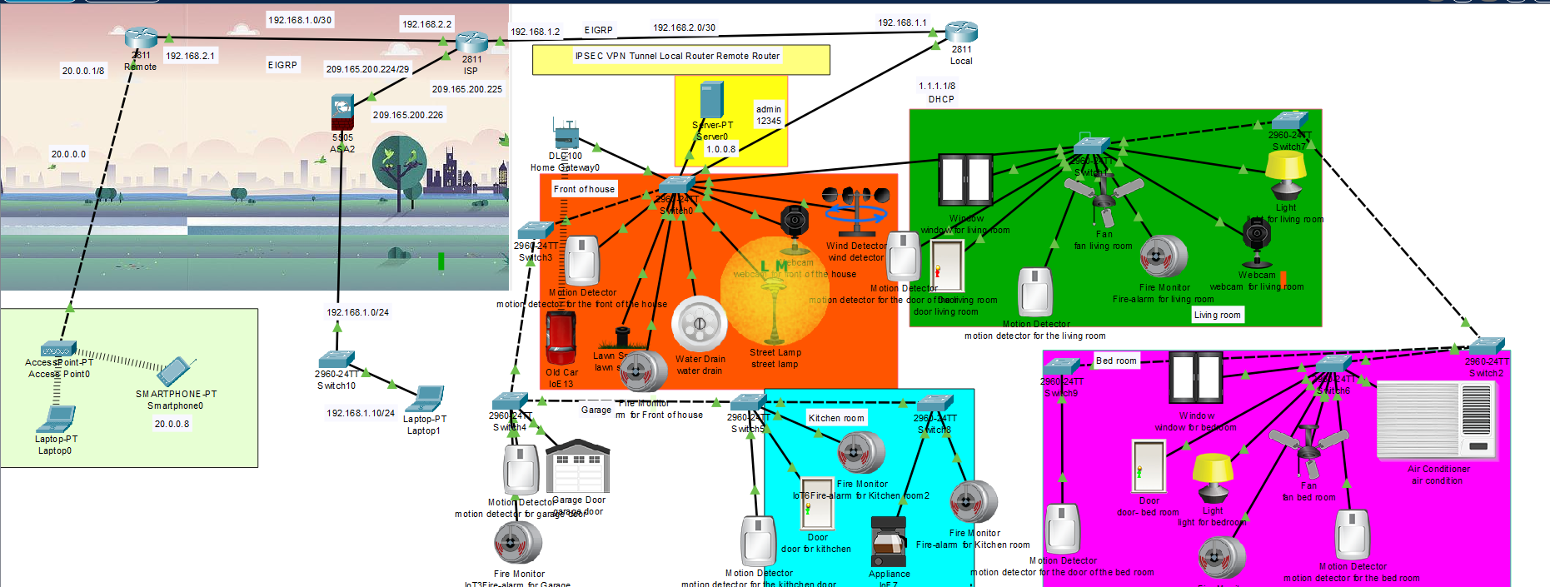

Figure simulation topology

# **Addressing Table**

Table 3.5. Addressing Table

|  |  |  |
| --- | --- | --- |
|  |  |  |
| Front of house | | |
| motion detector for the front of the house | 1.0.0.5 |  |
| lawn sprinkler | 1.0.0.14 |  |
| Fire-alarm for Front of house | 1.0.0.27 |  |
| water drain | 1.0.0.12 |  |
| street lamp | 1.0.0.13 |  |
| webcam for front of the house | 1.0.0.16 |  |
| wind detector | 1.0.0.17 |  |
| IoE13 | 192.168.25.100 |  |
| Garage | | |
| IoT3Fire-alarm for Garage | 1.0.0.29 |  |
| garage door | 1.0.0.9 |  |
| motion detector for garage door | 1.0.0.7 |  |
| Living room | | |
| light for living room | 1.0.0.18 |  |
| webcam for living room | 1.0.0.1 |  |
| Fire-alarm for living room | 1.0.0.26 |  |
| fan living room | 1.0.0.4 |  |
| motion detector for the living room | 1.0.0.6 |  |
| window for living room | 1.0.0.25 |  |
| motion detector for the door of the living room | 1.0.0.3 |  |
| door living room | 1.0.0.2 |  |
|  |  |  |
| Bed room | | |
| **air condition** | 1.0.0.24 |  |
| motion detector for the bed room | 1.0.0.23 |  |
| fan bed room | 1.0.0.20 |  |
| Fire-alarm for Bed Room | 1.0.0.28 |  |
| light for bedroom | 1.0.0.22 |  |
| door- bed room | 1.0.0.19 |  |
| window for bedroom | 1.0.0.4 |  |
| motion detector for the door of the bed room | 1.0.0.21 |  |
| Kitchen room | | |
| Fire-alarm for Kitchen room | 1.0.0.30 |  |
| IoE7 | 1.0.0.11 |  |
| IoT6Fire-alarm for Kitchen room2 | 1.0.0.31 |  |
| door for kithchen | 1.0.0.10 |  |
| motion detector for the kithchen door | 1.0.0.15 |  |
|  |  |  |
| 9 2960 switches |  |  |
| Remote Router | | |
| F0/0 | 192.168.2.1/30 |  |
| F0/1 | 20.0.0.1/8 |  |
| Local Router | | |
| F0/0 | 1.1.1.1/8 |  |
| F0/1 | 192.168.1.1/30 |  |
| ISP | | |
| F0/0 | 192.168.2.2/30 |  |
| F0/1 | 192.168.1.2/30 |  |
| Ethernet0/0 | 209.165.200.255/29 |  |
| ASA | | |
| Ethernet0/0 | 209.165.200.226/29 |  |
| Ethernet0/1 | 192.168.1.1/24 |  |
| End devices | | |
| Laptop1 | 192.168.1.10/24 | Gateway 192.168.1.1 |
| Laptop0 | 20.0.0.2/8 | Gateway  20.0.0.1 |
| Smartphone0 | 20.0.0.8/8 | Gateway  20.0.0.1 |
| Server0 | 1.0.0.8/8 | Gateway  1.1.1.1 |
|  |  |  |
| Home Gateway | 192.168.25.1 |  |
| Access point0 |  |  |

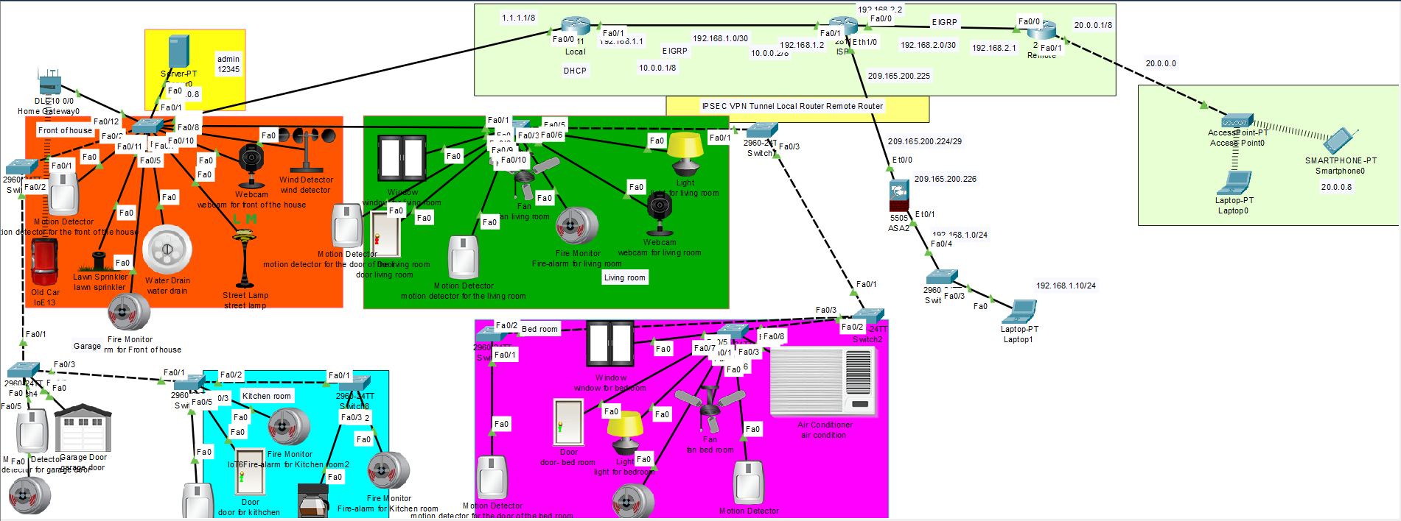



# **ASA Firewall**

Table ASA configuration

|  |
| --- |
| !  interface Vlan1  nameif inside  security-level 100  ip address 192.168.1.1 255.255.255.0  interface vlan 2  ciscoasa(config-if)#ip address 209.165.200.226 255.255.255.248  ciscoasa(config-if)#route outside 0.0.0.0 0.0.0.0 209.165.200.225  object network inside-net  subnet 192.168.1.0 255.255.255.0  nat (inside,outside) dynamic interface  configure t  class-map inspect  ciscoasa(config-cmap)#match default-inspection-traffic  policy-map global_policy  class map inspection_default  service-policy global_policy global  dhcpd address 192.168.1.10-192.168.1.30 inside  dhcpd dns 8.8.8.8 interface inside  dhcpd enable inside  access-list inside-outside2 extended permit icmp any any  access-group inside-outside2 in interface outside |

# **IPSEC VPN Tunnel**

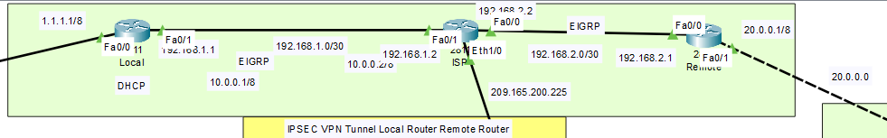

Figure ipsec VPN

# **Remote Router IPSEC VPN Tunnel**

Table remote router configuration

|  |
| --- |
| Remote Router  !  crypto isakmp policy 1  encr 3des  hash md5  authentication pre-share  group 2  !  crypto isakmp key Gns3Network address 192.168.1.1  !  !  !  crypto ipsec transform-set TSET esp-3des esp-md5-hmac  !  crypto map CMAP 1 ipsec-isakmp  ! Incomplete  set transform-set TSET  match address ipsec_list  !  !  !  !  !  !  ip access-list extended ipsec_list  permit ip 20.0.0.0 0.255.255.255 1.0.0.0 0.255.255.255  !  !  ! |

# **Local Router IPSEC VPN Tunnel**

Table local router configuration

|  |
| --- |
| !  crypto isakmp policy 1  encr 3des  hash md5  authentication pre-share  group 2  !  crypto isakmp key Gns3Network address 192.168.2.1  !  !  !  crypto ipsec transform-set TSET esp-3des esp-md5-hmac  !  crypto map CMAP 1 ipsec-isakmp  set peer 192.168.2.1  set transform-set TSET  match address ipsec_list  !  !  !  !  ip access-list extended ipsec_list  permit ip 1.0.0.0 0.255.255.255 20.0.0.0 0.255.255.255  !  !  ! |

# **EIGRP**

Table eigrp

|  |
| --- |
| Local Router !  router eigrp 1  network 1.0.0.0  network 192.168.1.0  ! Remote Router !  router eigrp 1  network 192.168.2.0  network 20.0.0.0  ! ISP Ruoter !  router eigrp 1  network 192.168.1.0  network 192.168.2.0  network 209.165.200.0 ASA !  route outside 0.0.0.0 0.0.0.0 209.165.200.225 1  ! |

# **DHCP service**

Table Enable DHCP service

|  |
| --- |
| Local Router !  ip dhcp pool network  network 1.0.0.0 255.0.0.0  default-router 1.1.1.1  dns-server 1.1.1.2  ip dhcp pool 20network  network 10.0.0.0 255.0.0.0  default-router 20.0.0.1  dns-server 10.0.0.2 Remote Router !  ip dhcp pool 20  network 20.0.0.0 255.0.0.0  default-router 20.0.0.1  !  ! ASA dhcpd address 192.168.1.10-192.168.1.30 inside  dhcpd dns 8.8.8.8 interface inside  dhcpd enable inside |

# **Server Reachability**

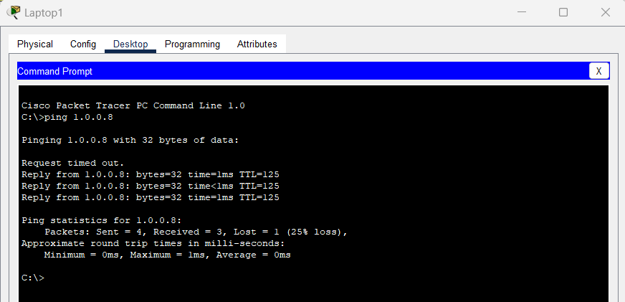

Figure server reachability

# **Devices configuration**

This Figure 3.5 below show the simulation of the smart home with cisco packet tracer using the Methodology described in the previous page. Home gateway, cloud, ISP (internet service provider) router, central office server, IoT (internet of things) Server, smart phone.



Figure topology

Figure 3.5. Smart home with Cisco Packet Tracer

-**Home gateway** = used for assigning IP address to the smart devices and for smart devices registration. The home gateway get the IP address from the ISP Router automatically after that the connection to the cloud WAN is established. Also all the smart object connected to the home gateway get an IP address from ISP router automatically via the cloud (WAN). The cable modem is used to connect the home gateway to the cloud. The home gateway provide different programing environment to the devices. In the Figure 3.6 above, we can see different smart objects connected to the home gateway using wireless or Ethernet cable connection.

There are four Ethernet ports in the home gateway plus a wireless access point with the SSID “home gateway”. We can configure WEP / WPA –PSK/ WPA2 protocols in the home gateway for the wireless connection authentication. In order to connect the devices to the home gateway, we must select wireless since the devices will be connected using wireless connection, then we specify the SSID of the home gateway in the devices.

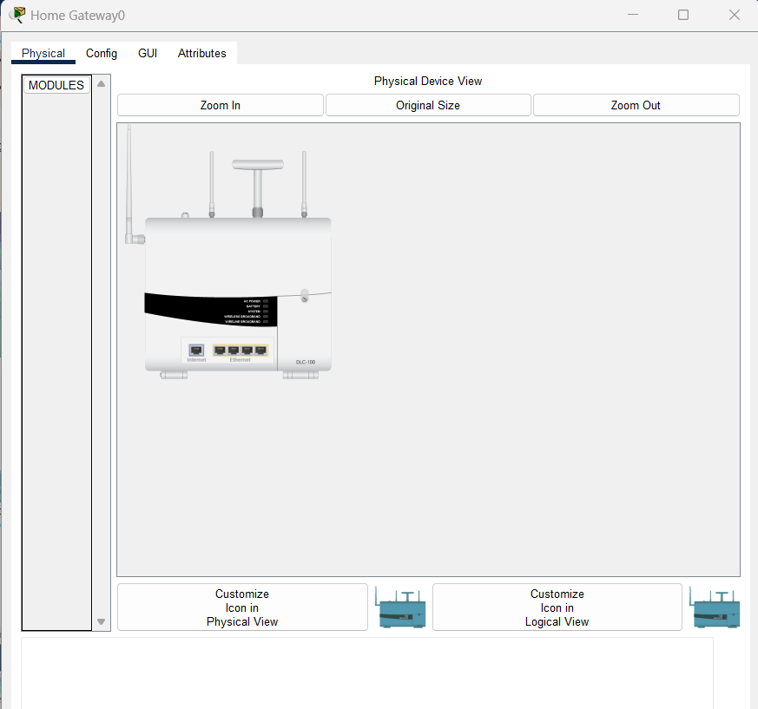

Figure home gateway

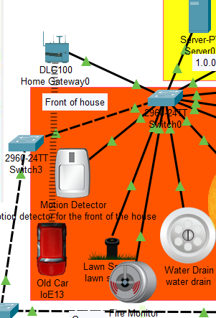

Figure Home Gateway

This Figure 3.7 is the smart light configuration to the home gateway. The authentication is disabled to just to keep the configuration simple. So we repeated this configuration in all the devices.

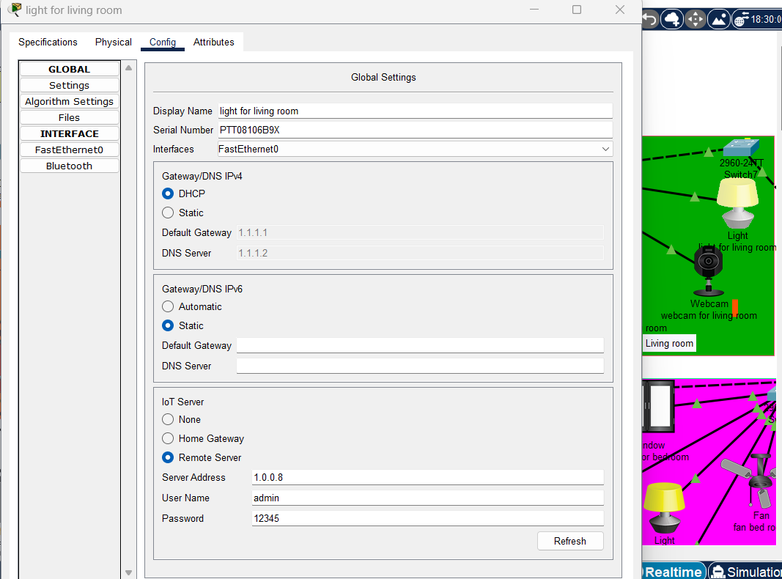

Figure Smart Light Connected to the Home Gateway

**ISP Router** (internet service provider) is used to connect all the network interfaces to each other, the DHCP server is configured on it in order to assign IP address to every connected devices dynamically, whether they are smart devices or not smart in order to simulate the internet connectivity. The ISP router configuration is done with the cisco packet tracer command line interface. The configuration consist of hostname assigning and IP address configuration

**-IOTserver:** is used to remotely connect the IoT devices on it in order to remotely acess them through a web interface using a computer or a smartphone. In general, all he smart objects registered on the IoE server can be remotely controlled via a web interface hosted on the IoT server.

The IoE server is configured with a static IP address in order for all the smart devices to connect to it utilizing the same IP address. Figure show the IP address configuration using Static.

The devices can be accessed using the username and password already created on the IOE server, therefore during the devices registration on the IOE server, the same username and password must be specified with the IOE server IP address.

# **Server Configuration**

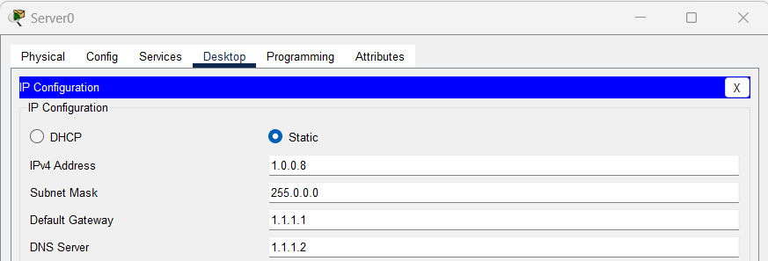

Figure server configuration

# **Set username and password for IOT server**

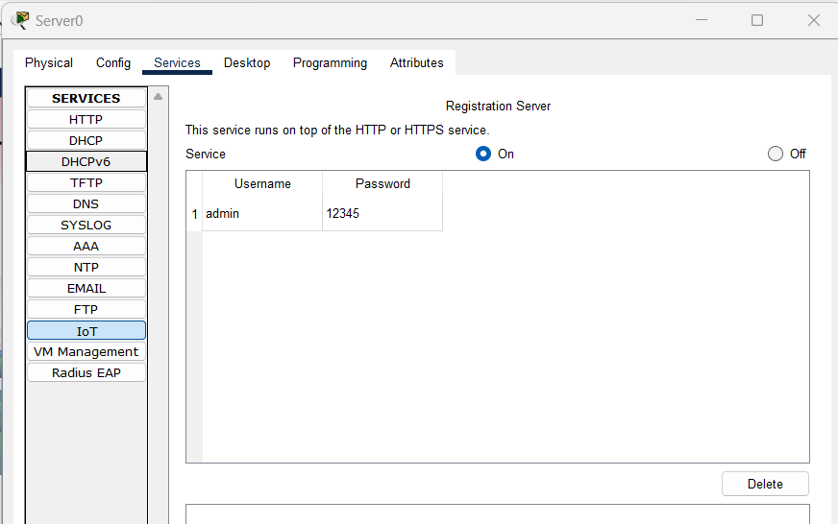

Figure set username and password for IOT server

# **Register to IOT server**

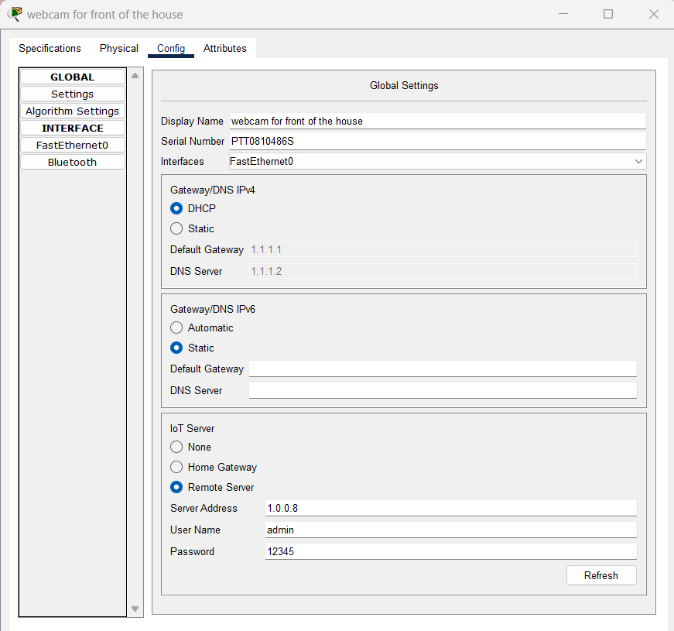

Figure Connecting IoT Devices to IoT Server

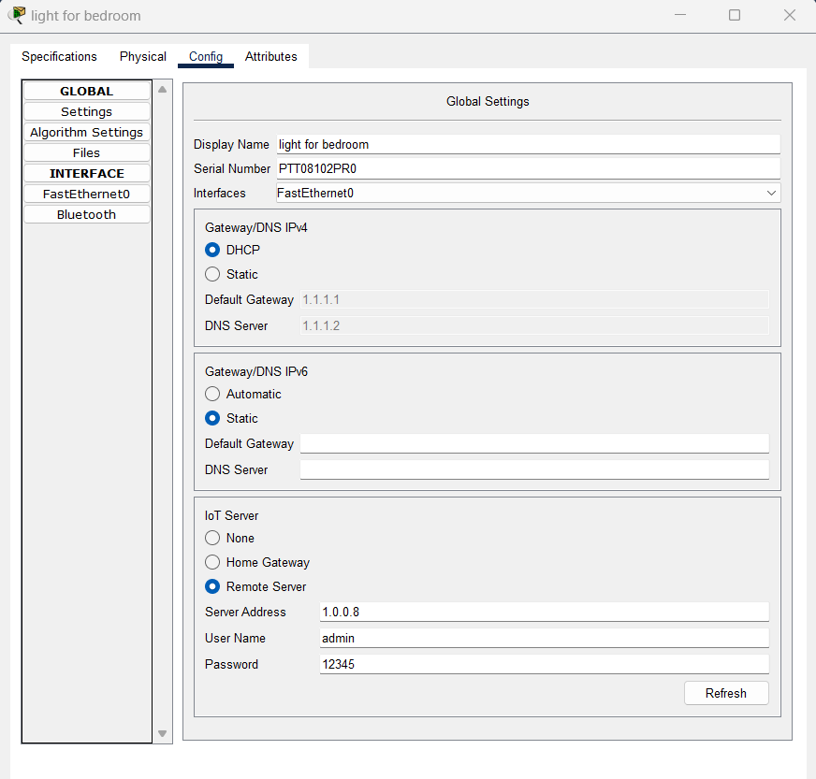

Figure Connecting IoT Devices to IoT Server

# **Manage IOT devices**

## Login to server and choose IOT Monitor

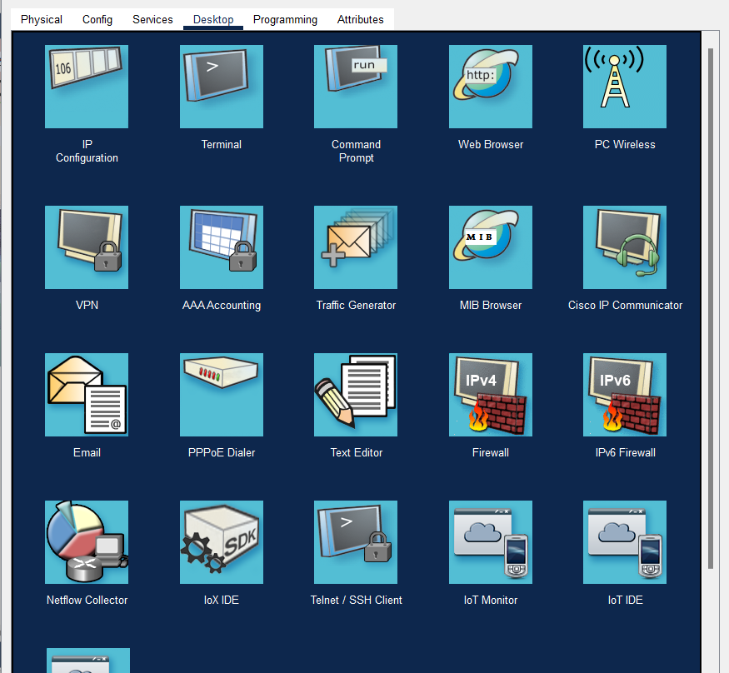

Figure iot monitor access

Figure select IOT Monitor

## Login to server 1.0.0.8

Username admin

Password 123456

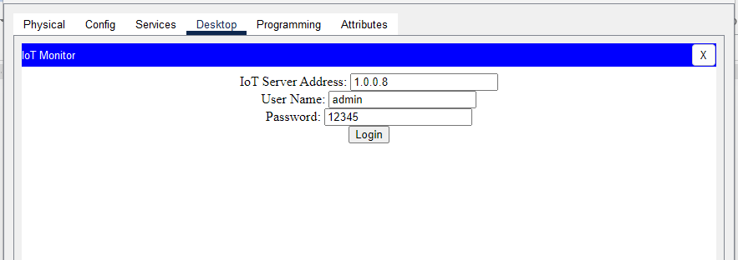

Figure login to IOT server

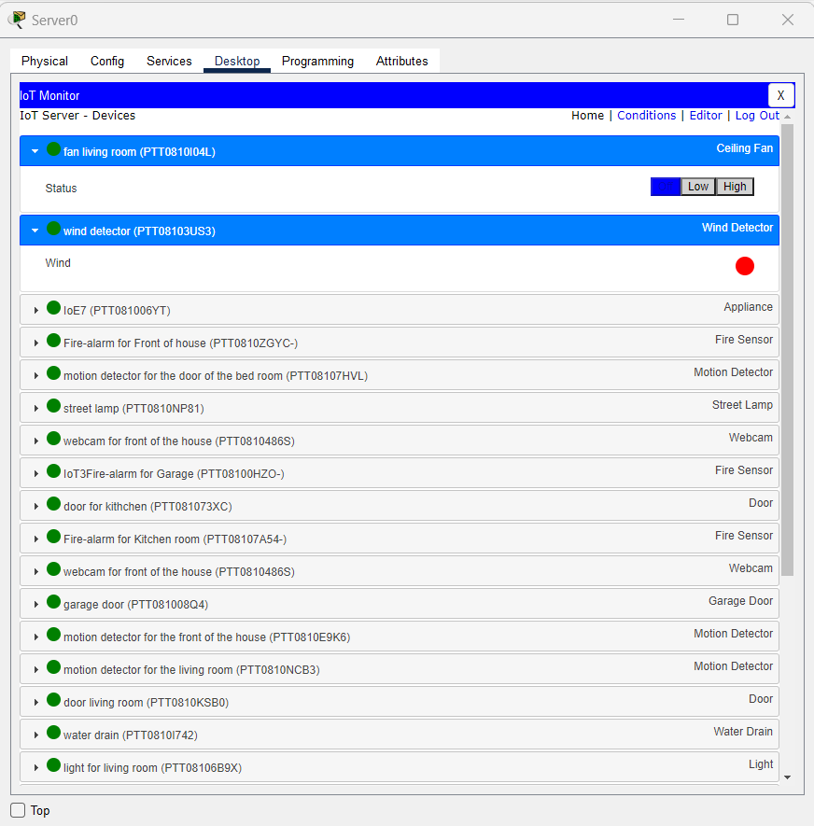

Figure IOT managed services

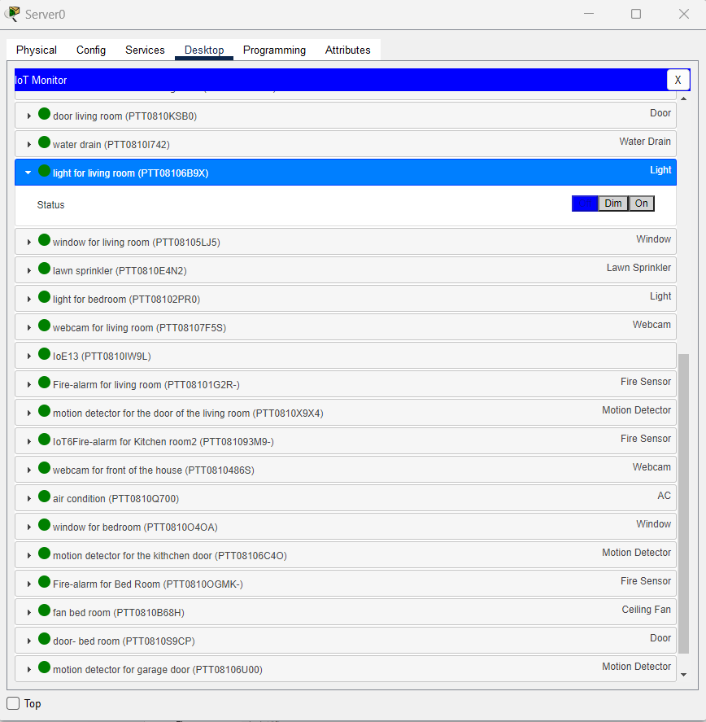

Figure IOT managed services

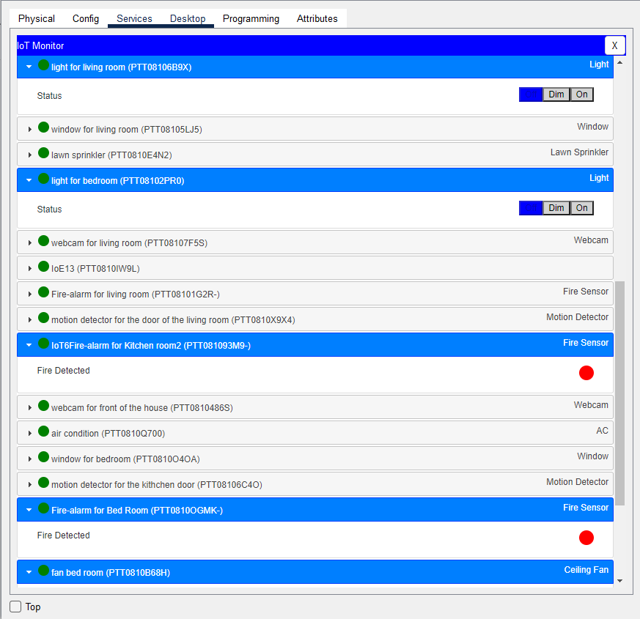

Figure IOT managed services

**Smartphone**: is used to remotely access the smart object through a web interface using the URL with an internet connection.

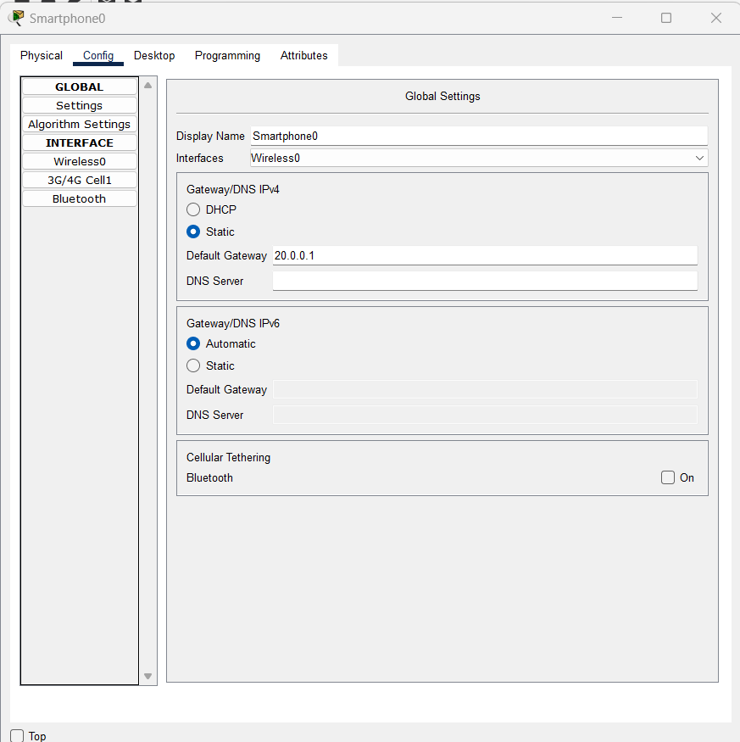

Figure Smart Phone Physical View

# **ISP Router**

Table ISP router

|  |
| --- |
| Router#sh run  Building configuration...  Current configuration : 871 bytes  !  version 15.1  no service timestamps log datetime msec  no service timestamps debug datetime msec  no service password-encryption  !  hostname Router  !  !  !  !  !  !  !  !  ip cef  no ipv6 cef  !  !  !  !  license udi pid CISCO2811/K9 sn FTX10170EHA-  !  !  !  !  !  !  !  !  !  !  !  spanning-tree mode pvst  !  !  !  !  !  !  interface FastEthernet0/0  ip address 192.168.2.2 255.255.255.252  duplex auto  speed auto  !  interface FastEthernet0/1  ip address 192.168.1.2 255.255.255.252  duplex auto  speed auto  !  interface Ethernet1/0  ip address 209.165.200.225 255.255.255.248  duplex auto  speed auto  !  interface Ethernet1/1  no ip address  duplex auto  speed auto  !  interface Vlan1  no ip address  shutdown  !  router eigrp 1  network 192.168.1.0  network 192.168.2.0  network 209.165.200.0  !  ip classless  !  ip flow-export version 9  !  !  !  !  !  !  !  line con 0  !  line aux 0  !  line vty 0 4  login  !  !  !  end  Router# |

# **Remote Router**

Table remote router

|  |
| --- |
| Router#sh run  Building configuration...  Current configuration : 1142 bytes  !  version 15.1  no service timestamps log datetime msec  no service timestamps debug datetime msec  no service password-encryption  !  hostname Router  !  !  !  !  !  ip dhcp pool 20  network 20.0.0.0 255.0.0.0  default-router 20.0.0.1  !  !  !  ip cef  no ipv6 cef  !  !  !  !  license udi pid CISCO2811/K9 sn FTX1017FBJS-  !  !  !  crypto isakmp policy 1  encr 3des  hash md5  authentication pre-share  group 2  !  crypto isakmp key Gns3Network address 192.168.1.1  !  !  !  crypto ipsec transform-set TSET esp-3des esp-md5-hmac  !  crypto map CMAP 1 ipsec-isakmp  ! Incomplete  set transform-set TSET  match address ipsec_list  !  !  !  !  !  !  spanning-tree mode pvst  !  !  !  !  !  !  interface FastEthernet0/0  ip address 192.168.2.1 255.255.255.252  duplex auto  speed auto  crypto map CMAP  !  interface FastEthernet0/1  ip address 20.0.0.1 255.0.0.0  duplex auto  speed auto  !  interface Vlan1  no ip address  shutdown  !  router eigrp 1  network 192.168.2.0  network 20.0.0.0  !  ip classless  !  ip flow-export version 9  !  !  ip access-list extended ipsec_list  permit ip 20.0.0.0 0.255.255.255 1.0.0.0 0.255.255.255  !  !  !  !  !  line con 0  !  line aux 0  !  line vty 0 4  login  !  !  !  end  Router# |

# **Local Router**

Table local router

|  |
| --- |
| Router#  Router#sh run  Building configuration...  Current configuration : 1268 bytes  !  version 15.1  no service timestamps log datetime msec  no service timestamps debug datetime msec  no service password-encryption  !  hostname Router  !  !  !  !  !  ip dhcp pool network  network 1.0.0.0 255.0.0.0  default-router 1.1.1.1  dns-server 1.1.1.2  ip dhcp pool 20network  network 10.0.0.0 255.0.0.0  default-router 20.0.0.1  dns-server 10.0.0.2  !  !  !  ip cef  no ipv6 cef  !  !  !  !  license udi pid CISCO2811/K9 sn FTX1017T662-  !  !  !  crypto isakmp policy 1  encr 3des  hash md5  authentication pre-share  group 2  !  crypto isakmp key Gns3Network address 192.168.2.1  !  !  !  crypto ipsec transform-set TSET esp-3des esp-md5-hmac  !  crypto map CMAP 1 ipsec-isakmp  set peer 192.168.2.1  set transform-set TSET  match address ipsec_list  !  !  !  !  !  !  spanning-tree mode pvst  !  !  !  !  !  !  interface FastEthernet0/0  ip address 1.1.1.1 255.0.0.0  duplex auto  speed auto  !  interface FastEthernet0/1  ip address 192.168.1.1 255.255.255.252  duplex auto  speed auto  crypto map CMAP  !  interface Vlan1  no ip address  shutdown  !  router eigrp 1  network 1.0.0.0  network 192.168.1.0  !  ip classless  !  ip flow-export version 9  !  !  ip access-list extended ipsec_list  permit ip 1.0.0.0 0.255.255.255 20.0.0.0 0.255.255.255  !  !  !  !  !  line con 0  !  line aux 0  !  line vty 0 4  login  !  !  !  end  Router# |

# **Results**

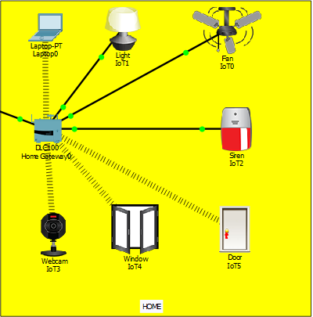

Figure iot devices after action

The figure above shows the light is on , the fan is moving at high speed , the door is unlocked , the siren is on , the window is open and webcam has started recording . This is based on the conditions made on the Home Gateway that the legitimate user is able to control the brightness of light (off , dim , on) , control fan speed (off , medium , high) , control door (lock , unlock) , control window (open , close) and monitor webcam recording.

After the successful connection to the server, the data of sensor are sent to the web server for monitoring of the system. the web server page which will allow us to monitor and control the system. By entering the assigned IP address in the web browser this web server page will appear. The web server gives the information about the temperature in different places of the house and motion state in the house. It also gives the status of the various electrical appliances like light, fan etc which we can control remotely.

While all the devices have been configured, they can all be accessed through a web browser of the smartphone with the URL www.10.0.0.8 using the correct user name and password. After being connected to the IoT homepage through browser and successfully passing the authentication, the user can then see the list of the connected devices and perform the action he want.

# **Conclusion**

In this project, I implemented smart home using cisco packet. I used home Gateway to register smart device on it to control them and interconnect different sensors.

As we all are aware that the world is getting more and more connected and IoT does just that. Many tech entrepreneurs are already starting off with IoT and making huge profits out of it. Keeping the profits aside, if we think of it in a broader way, then we conclude that IoT has a great future and in the next five years, it is going to revolutionize the world. IoT is like clay that can be moulded in any way we wish, if provided with enough skills and expertise.

The home automation using Internet of Things has been experimentally proven to work satisfactorily by connecting simple appliances to it and the appliances were successfully controlled remotely through internet. The designed system not only monitors the sensor data, like temperature, gas, light, motion sensors, but also actuates a process according to the requirement, for example switching on the light when it gets dark.

CHAPTER 4 CONCLUSION

# CHAPTER 4 CONCLUSION

# **4.1. Conclusion:**

This research work was to simulate the internet of things using a cisco packet tracer. Internet of Things is a new revolutionary and advanced technology, therefore the need to have a virtual practical tool where students can learn and understand this technology was necessary. That is the motivation behind this research.

I choose cisco packet tracer because it offers a simulation environment with devices that look like devices in real life, also within the new version of the packet tracer we can find many internet of things devices, actuator and other sensors, which make the cisco packet tracer the suitable simulator for internet of things.

The ideas was to implement and simulate a very famous internet of things application that is the smart home using cisco packet tracer. The implementation is done using the latest version of the cisco packet tracer because this version included many smart devices used for smart home. Many others network devices are used in order to achieve the simulation, those are gateway, router, cable modem, IoT and DNS servers, Router, switch, cell tower, cloud WAN, central office sever and a smartphone.

The home gateway is used in order to connect different smart devices on it and IP address distribution to those smart devices via wireless network. The IoT server and the smartphone play a very important role in the simulation because, they permit to remotely control the Iot devices via internet. The IoT server is used for smart devices registration while the smartphone is used remotely access the smart devices registered on the IoT server.

The utilizing of various internet of things devices and network devices included in cisco packet tracer made the simulation easy and also more IoT devices will be included in the upcoming version of the cisco packet tracer, so more complex IoT simulation can be made.

# **4.2. Future Research**

There are many Simulator used to simulate IoT technology. Therefore, future research can be the comparison between cisco packet tracer with others IoT simulations. Also add programming codes to make lab smarter.

# **References**

[1] Chattoraj, Subhankar. "Smart Home Automation based on different sensors and Arduino as the master controller." International Journal of Scientific and Research Publications5.10 (2015): 1-4.

[2] Soliman, Moataz, et al. "Smart home: Integrating internet of things with web services and cloud computing." Cloud Computing Technology and Science (CloudCom), 2013 IEEE 5th International Conference on. Vol. 2. IEEE, 2013

[3] S. Haller S. Karnouskos and C. Schroth "The Internet of Things in an Enterprise Context " in Future Internet-FIS 2008 Lecture Notes in Computer Science Vol. 5468 2009 pp 14-28.

[4] Jie, Yin, et al. "Smart home system based on iot technologies." Computational and Information Sciences (ICCIS), 2013 Fifth International Conference on. IEEE, 2013

[5] <http://www.packettracernetwork.com/>

[6] Qin, X. U. E. "Simulation Experimental Teaching of Computer Network Based on Packet Tracer [J]." Research and Exploration in Laboratory 2 (2010): 57-59.

[7] <http://www.packettracernetwork.com/internet-ofthings/pt7-iot-devicesconfiguration.htm>

[8] Sun, Liangxu, et al. "Comparison between physical devices and simulator software for Cisco network technology teaching." Computer Science & Education (ICCSE), 2013 8th International Conference on. IEEE, 2013.